**DSP Experiment 5**

**Problem Statement:**

Write a sample user interactive script to plot magnitude and phase responses of Type-1, Type-2, Type-3 and Type-4 sequences.

a) The script must take any sequence (minimum length 6) as an input and output corresponding Type, its magnitude and phase response.

b) Apply a real audio signal to the filters in part (a). Observe the output and comment.

**Code:**

clc;

clear all;

h=input("Enter impulse response:");

m=length(h);

temp=h;

L=0;

% T1

if rem(m,2)==1 && isequal(h,flip(temp))

L=(m-1)/2;

a=[h(L+1) 2*h(L:-1:1)];

n=(0:1:L);

w=(-500:1:500)'*pi/1000;

Hr=cos(w*n)*a';

figure()

subplot(211)

plot(w/pi,abs(Hr)/max(Hr))

xlabel("w");

ylabel("|H(w)|");

subplot(212)

plot(w,-(m-1)*w/2)

xlabel("w");

ylabel("<(w)");

disp("Type 1")

% T2

elseif rem(m,2)==0 && isequal(h,flip(temp))

L=m/2;

b=2*(h(L:-1:1));

n=(1:1:L);

n=n-0.5;

w=(-500:1:500)'*pi/1000;

Hr=cos(w*n)*b';

figure()

subplot(211)

plot(w/pi,abs(Hr)/max(Hr))

xlabel("w");

ylabel("|H(w)|");

subplot(212)

plot(w,-(m-1)*w/2)

xlabel("w");

ylabel("<(w)");

disp("Type 2")

% T3

elseif rem(m,2)==1 && isequal(h,-flip(temp))

L=(m-1)/2;

c=2*(h(L+1:-1:1));

n=(0:1:L);

w=(-500:1:500)'*pi/1000;

Hr=sin(w*n)*c';

figure()

subplot(211)

plot(w/pi,abs(Hr)/max(Hr))

xlabel("w");

ylabel("|H(w)|");

subplot(212)

plot(w,-((m-1)*w/2)+pi/2)

xlabel("w");

ylabel("<(w)");

disp("Type 3")

% T4

elseif rem(m,2)==0 && isequal(h,-flip(temp))

L=m/2;

d=2*(h(L:-1:1));

n=(1:1:L);

n=n-0.5;

w=(-500:1:500)'*pi/500;

Hr=sin(w*n)*d';

figure()

subplot(211)

plot(w/pi,abs(Hr)/max(Hr))

xlabel("w");

ylabel("|H(w)|");

subplot(212)

plot(w,-((m-1)*w/2)+pi/2)

xlabel("w");

ylabel("<(w)");

disp("Type 4")

else

fvtool(h,1);

disp("Not of any type");

end

b=h;

a=1;

Fs=8000;

Ts=1/Fs;

Ns=512;

t=[0:Ts:Ts*(Ns-1)];

x1=sin(2*pi*500*t);

x2=sin(2*pi*1000*t);

x3=sin(2*pi*2000*t);

x4=sin(2*pi*3000*t);

x=2+x1+x2+x3+x4;

y=filter(b,a,x);

figure();

n=length(x);

f=(0:Ns-1)*(Fs/Ns);

x1=fft(x,Ns);

y1=fft(y,Ns);

subplot(211);

plot(f,abs(x1));

title('Spectrum of Orignal Signal')

ylabel('|H(w)|')

xlabel('w')

subplot(212);

plot(f,abs(y1));

title('Spectrum of Filtered Signal')

ylabel('|H(w)|')

xlabel('w')

% Real Signal

[cat,fs]=audioread("Cat_Meow_2-Cat_Stevens.mp3");

cat=cat(:,1);

nc=length(cat);

disp(nc);

f=(-(nc/2):(nc/2)-1)*(fs/nc);

yc=filter(b,a,cat);

xc=fftshift(fft(cat));

yc=fftshift(fft(yc));

figure();

ylabel('|H(w)|')

xlabel('w')

subplot(211);

plot(f,abs(xc));

title('Spectrum of Original Signal')

subplot(212);

plot(f,abs(yc));

title('Spectrum of Filtered Signal')

**Output:**

Type 1:

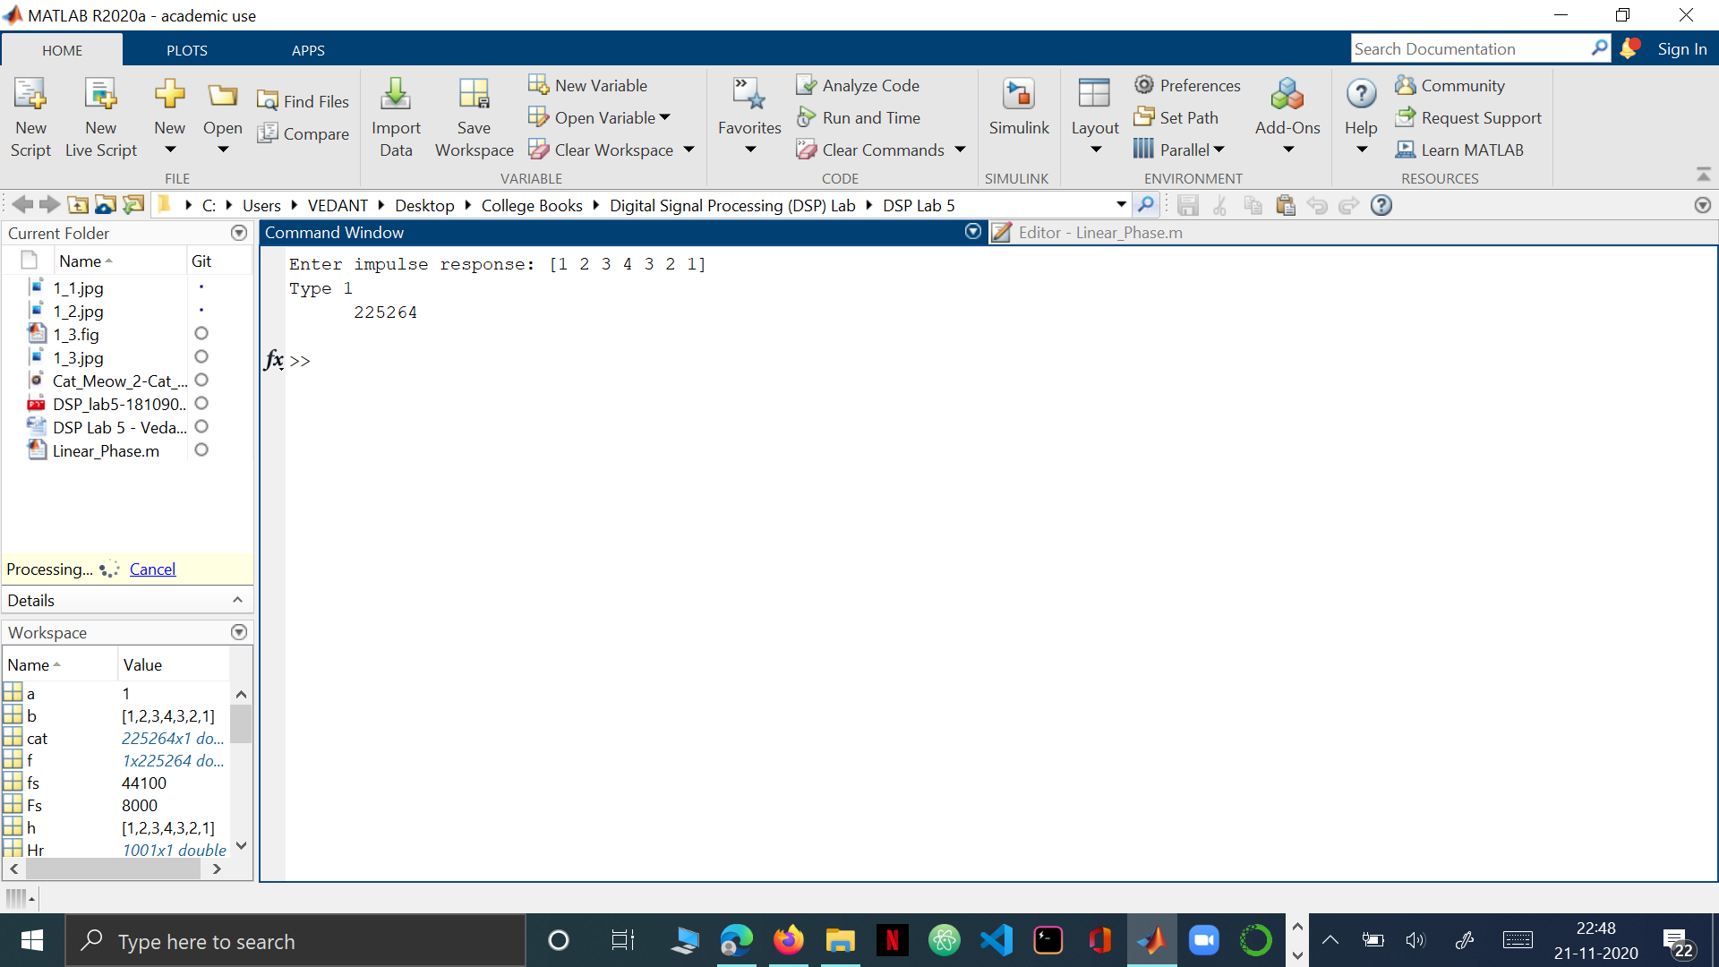

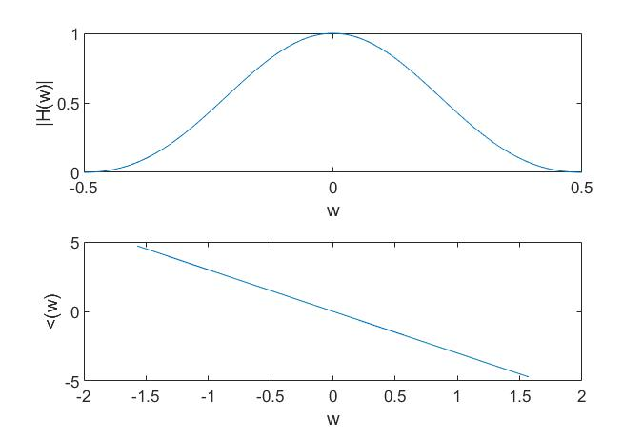

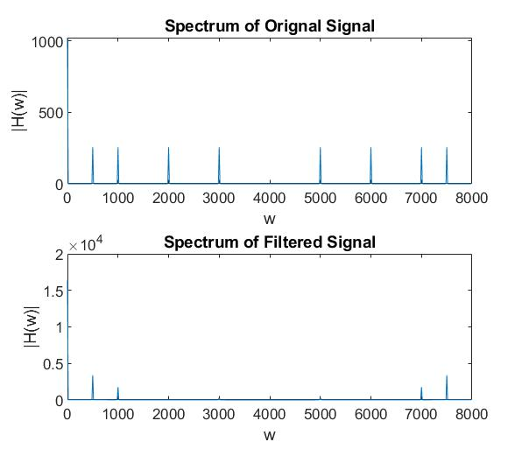

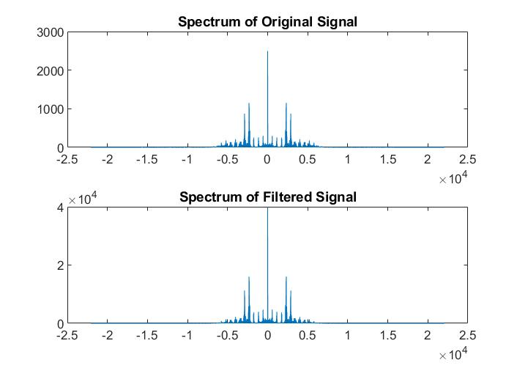

Type 2:

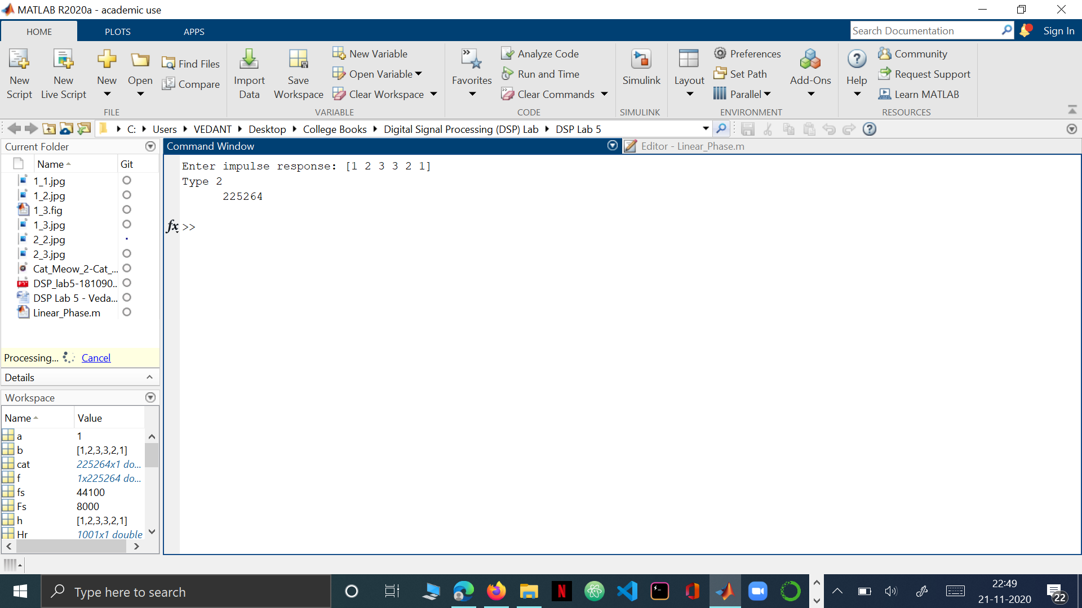

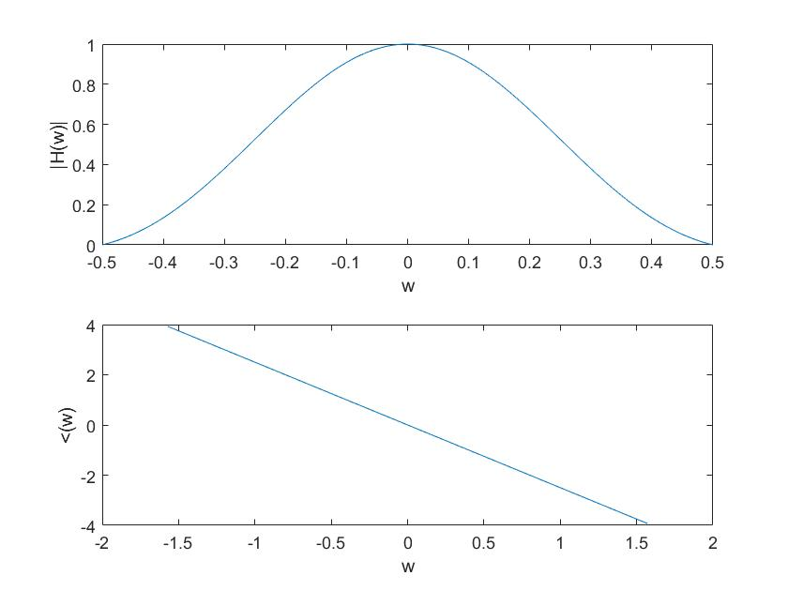

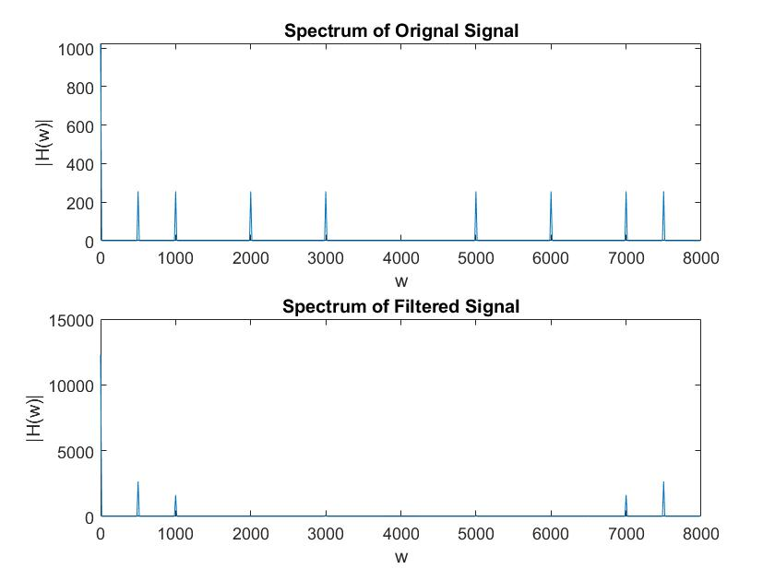

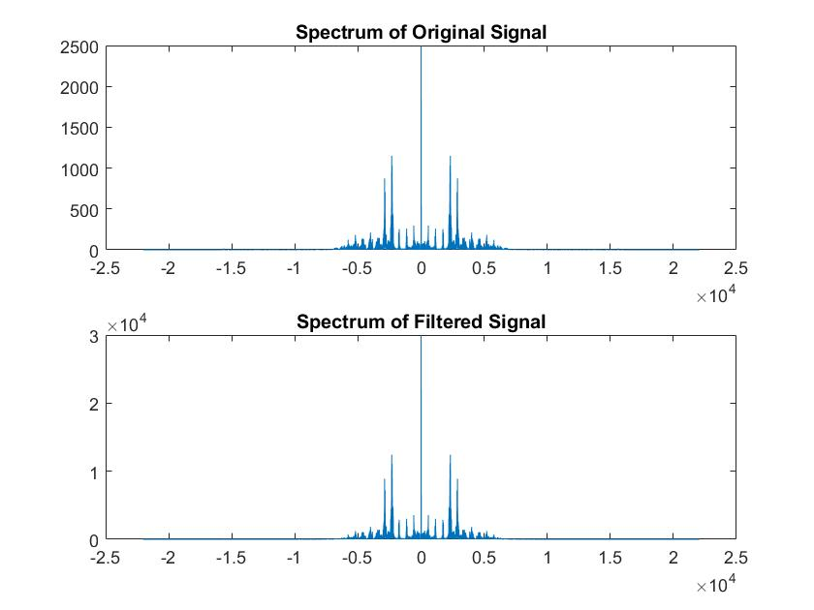

Type 3:

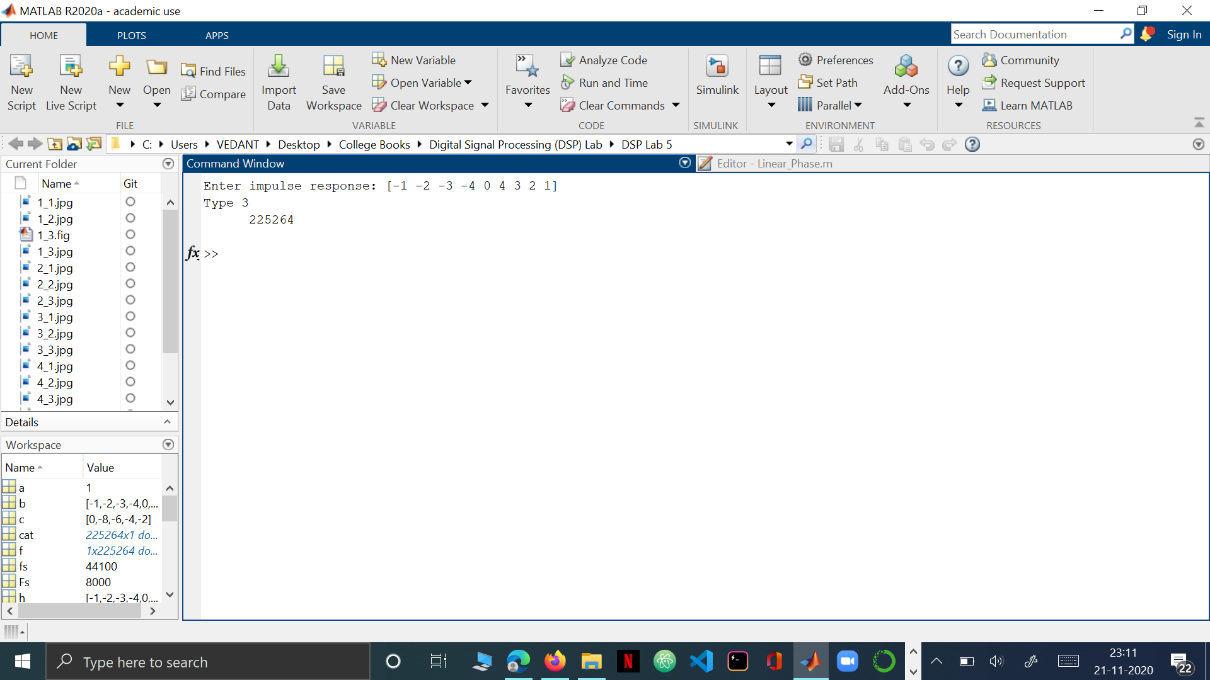

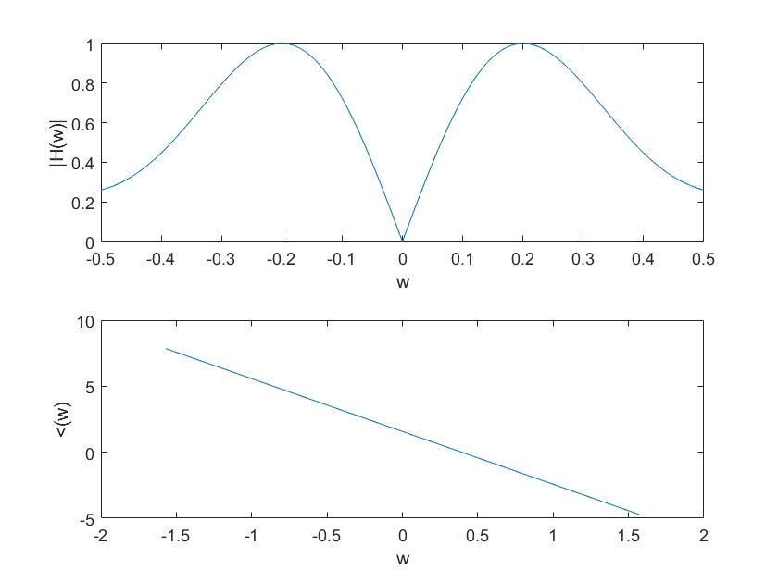

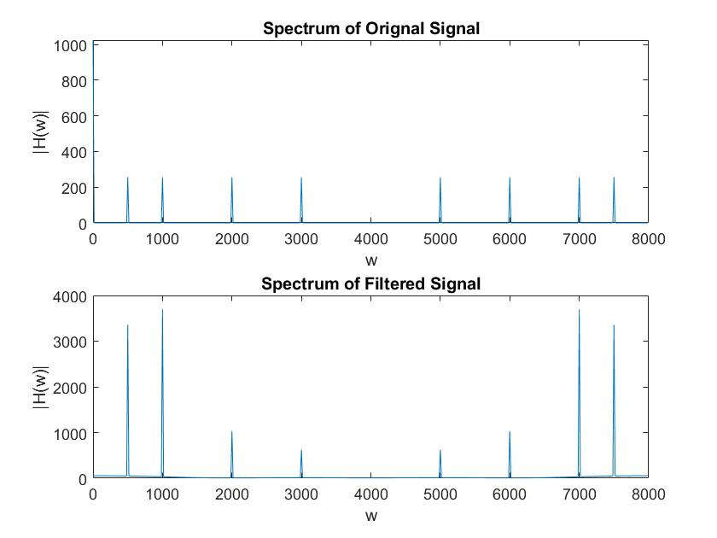

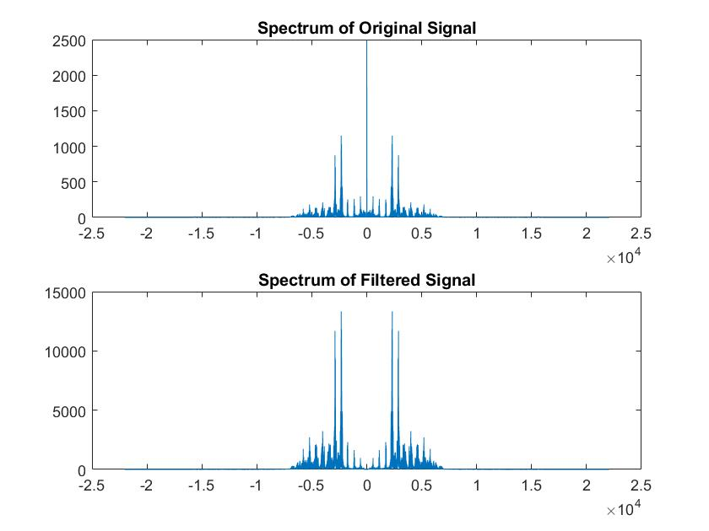

Type 4:

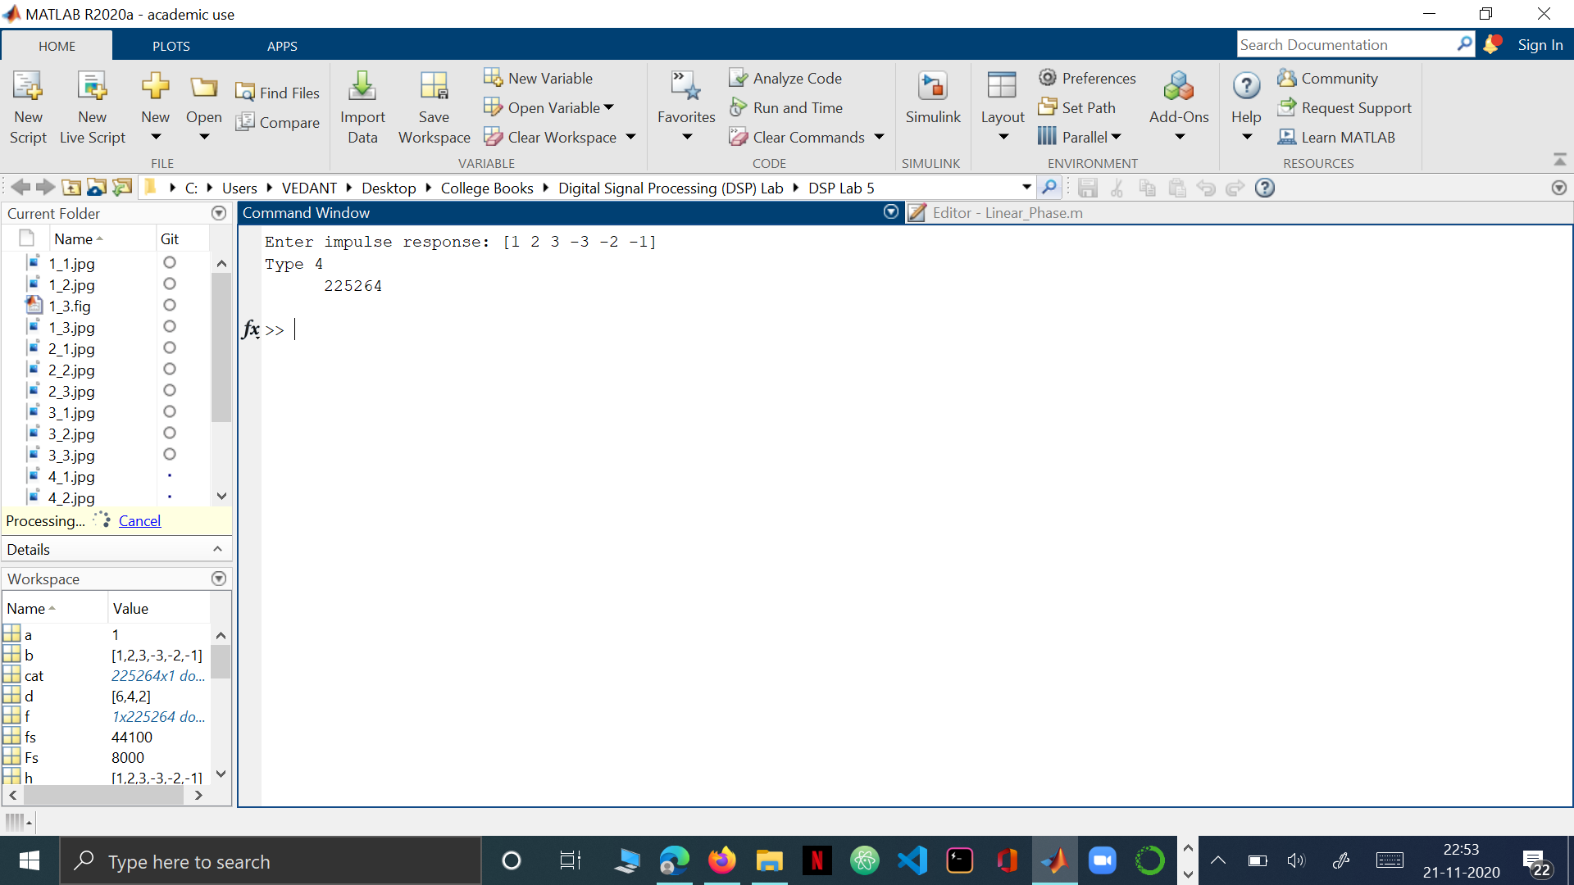

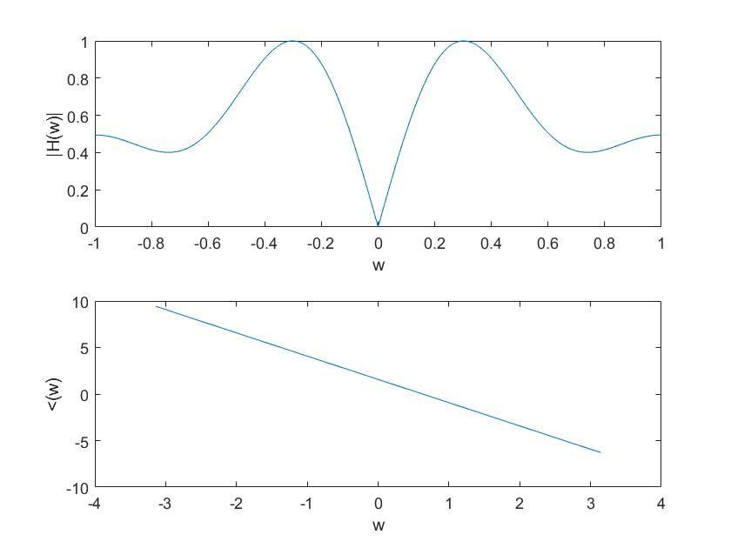

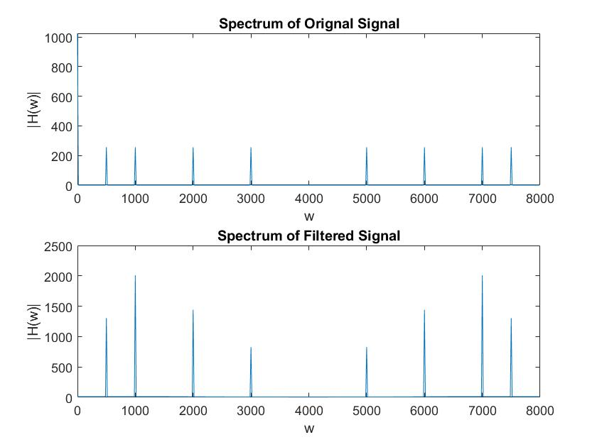

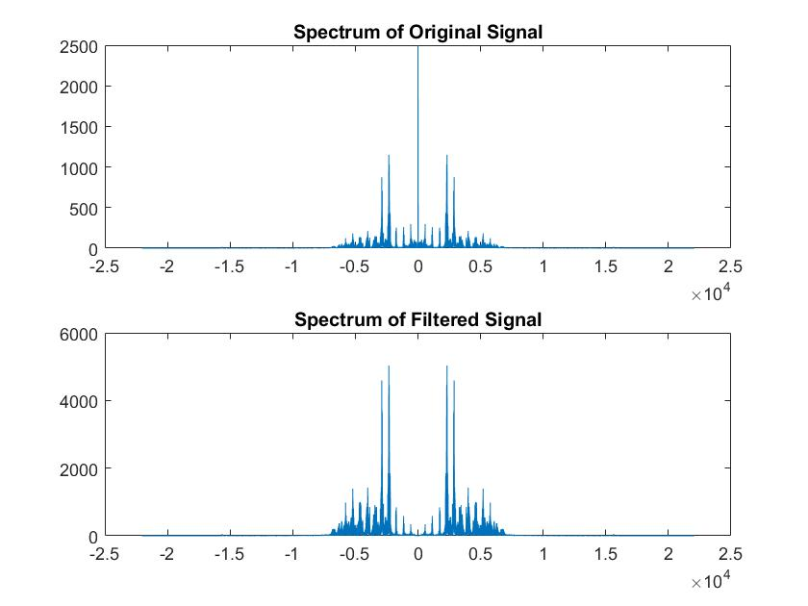

Type 5: (The Impulse Response Does not have a linear phase)

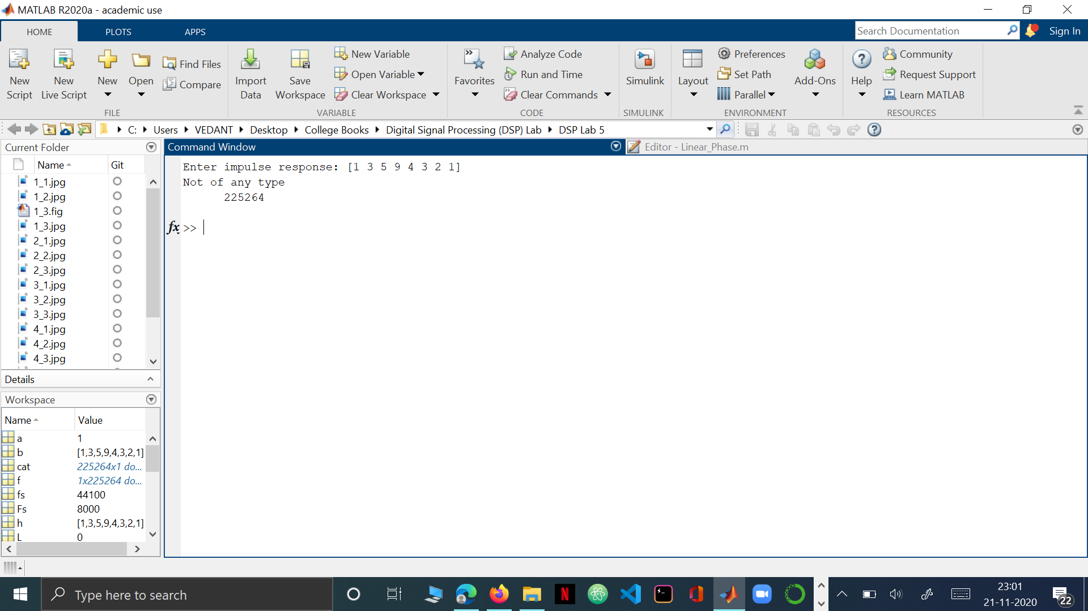  
  
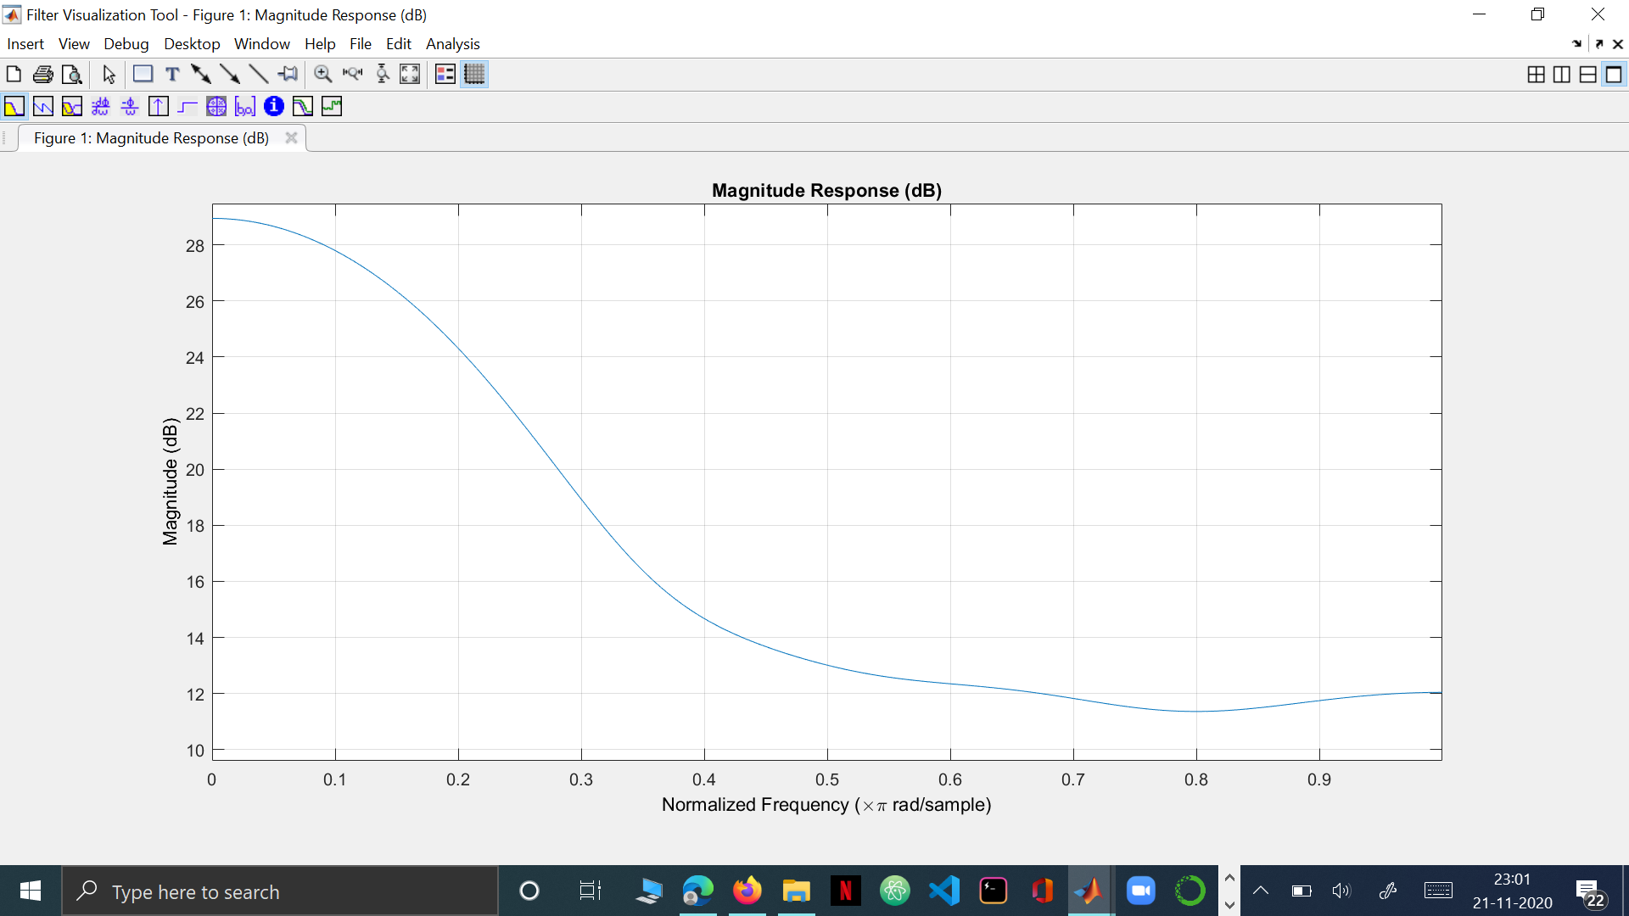

**Observation & Conclusion:**   
  
1. Type 1 filter is symmetric and of odd length. When the audio signal is passed, we can see that low frequencies are passed are high frequencies are rejected. It can behave as a Low Pass Filter or HPF or BPF or Band Reject Filter.   
  
2. Type 2 filter is symmetric and of even length. When the audio signal is passed, we can see that low frequencies are passed. It can behave as LPF or HPF and not BPF or Band Reject Filter.   
  
3. Type 3 filter is anti-symmetric and of odd length. When the audio signal is passed frequencies near 0 and higher frequencies are rejected. This filter behaves as a Band Pass Filter.   
  
  
4. Type 4 filter is anti-symmetric and of even length. When the audio signal is passed frequencies at 𝜔=0 are rejected. This filter behaves as a High Pass Filter.   
  
5. Type 5 filter, the non-symmetric impulse response doesn’t belong to any type.  
  
In the plots for the frequency spectrum for the convoluted signal, it is seen that the lower frequencies have disappeared and the higher frequencies remain the way they are which means they are passed through the high pass filter. Of all the five types, in the first four types of filters, there are spike observed where the phase response touches y=0.   
  
That is, when audio signal was given as an input to the type-2 filter, its frequency spectrum becomes 0 at 𝜔 =0 and magnitude remains as it is at 𝜔 =pi, i.e, it is passed through a high pass filter.  
  
Hence, we can say that different responses are obtained for the same input signals and what we observed here is that the types of filters are nothing but an output of small tweaks that we make to the symmetry and length of the impulse responses.